**Coins, Crystals, Diamonds vector icons for IAP**

This is a small instruction for editing icons. I use Photoshop CC 2018, but you can use any other version.

After opening the icon in Photoshop, make sure that you have the Layers window open.

Window - Layers or F7:

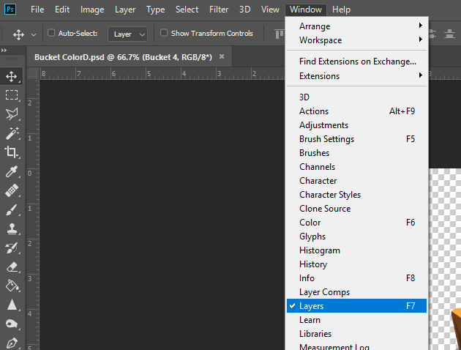

On the right side of Photoshop you will find this window.

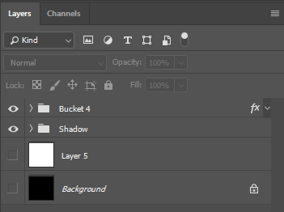

**How to remove the shadow?**

Click on the eye icon opposite the shadow layer to hide or restore the shadow.

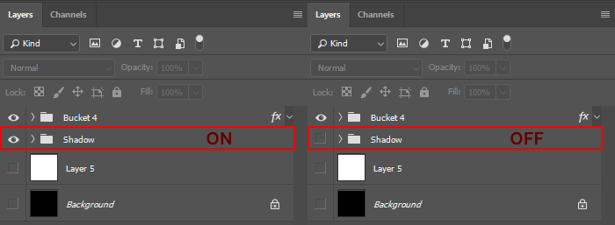

**How to adjust the stroke?**

Important: there is no stroke in the glow version of the crystals!

To enable the stroke, on the main folder you will find the fx icon. Click on the arrow to the right of fx, thereby expand it. On the left of the Stroke line, turn it on by clicking on the eye.

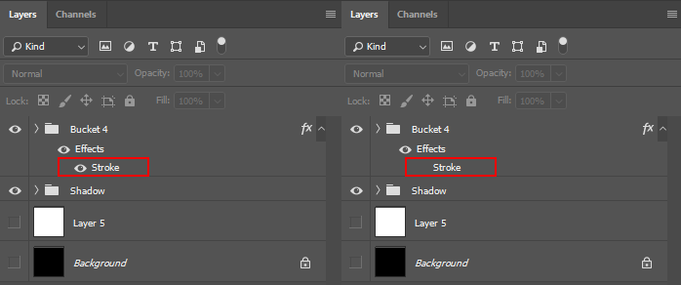

**How to change the stroke options?**

Right-click on the folder on which the Stroke is installed, select Blending options…

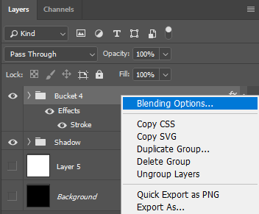

This window will open, in the left part of it, find the Stroke item and select it.

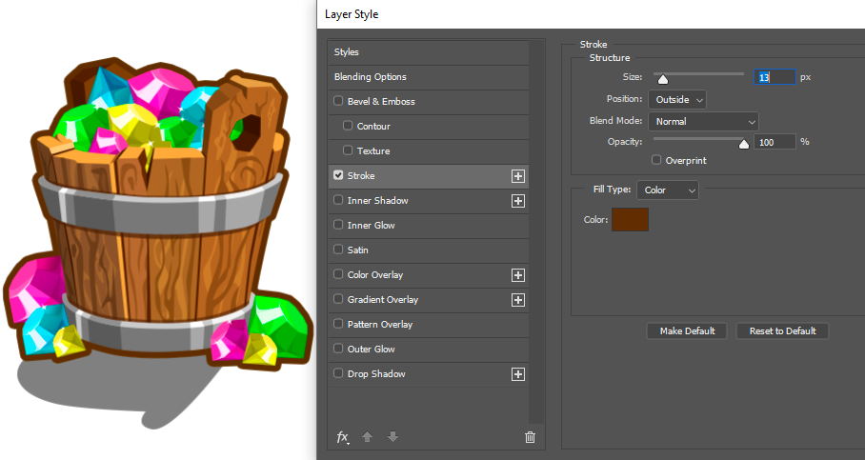

You can change the thickness of the Stroke, its position and color (double-click on the square with the color). After adjusting the stroke, click OK.

**How to adjust the glow?**

Open the icon from the Diamonds Glow folder.

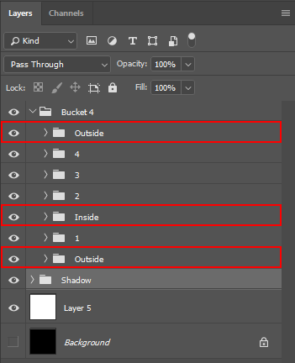

Expand the main folder (click on the arrow on the left). Inside you will find several folders Inside, Outside. There are crystals with a glow effect. Expand one of the folders.

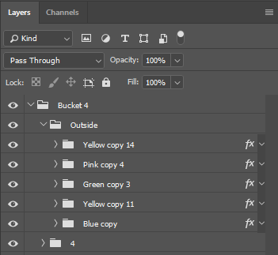

Each crystal has its own effect. Right-click on the folder, select Blending options… I circled in red all that you can change in the glow.

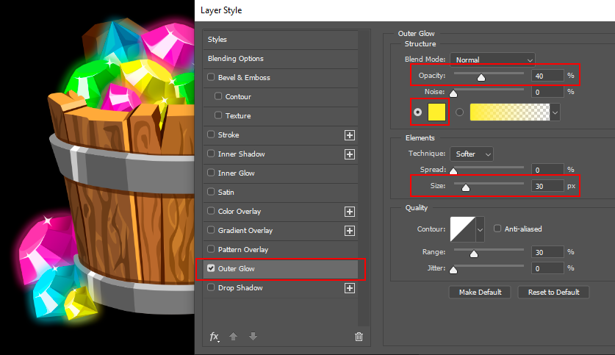

**How to resize a file in Photoshop?**

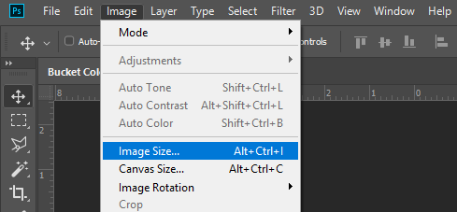

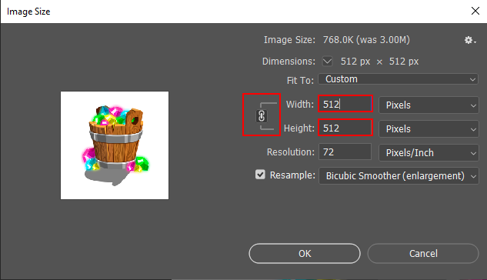

After editing the file, save your changes in the desired format.

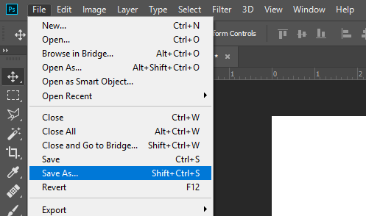

**Thank you for your attention and for buying my pack!**